0557EN 06.18

REHAU at SICAM 2024
Maximum freedom of design thanks to innovative materials
“Beauty for all shapes and forms” – this is the motto under which REHAU Interior Solutions will present its current product range at this year’s SICAM. At its impressive booth (Hall 5 – Booth E10/F11), REHAU will demonstrate how it helps industry and trade achieve freedom of design in form and function – with pioneering materials that, thanks to color and design combinations, enable perfect components for interiors that look as if they have been cast from a single mold.

Organic shapes in furniture construction are trending: curves in furniture, soft contours, warm color combinations – preferably with natural decor. This development poses challenges for manufacturers, whether from industry or manufacturing. Bending or shaping materials such as glass, stone or ceramic is difficult or even impossible. This is where REHAU materials come into play. The surfaces, edgebands and tambour doors make it easy to create slightly different shapes – using standard woodworking tools and with a high-quality look that is almost indistinguishable from the original material. How REHAU achieves this is one of the focal points at the SICAM booth. “We want to inspire our visitors and show them what’s possible. That’s why we are focusing on the theme of organic shapes,” says Jochen Luft, Sales Director Industry at REHAU. “Curves in interiors are currently very popular. And with our inspiring exhibits, we aim to show how easy it is to create organic shapes with our materials.” But it is not just the material properties that ensure creative freedom – exceptional design is supported by trendy decors, a variety of colors and the concept of the design match: surfaces, edgebands and storage space variants merge into holistic furniture as if from a single source. For example, REHAU will be presenting an interactive kitchen at the trade fair booth that playfully illustrates the design match across different material and product solutions.

RAUVISIO: flexibly processable surface with new colors and decors
The possibility of working flexibly with REHAU products, including shaping them into organic structures, is just one of the ways in which REHAU gives furniture manufacturers more freedom. The popular RAUVISIO collections are also being expanded with a variety of new colors and decors in line with current global trends. For example, the RAUVISIO crystal Collection – the plain color palette of the smart glass laminate – now features five new colors in high gloss and matt. A dark blue with a delicate green shimmer represents calm and stability; light blue radiates lightness and openness. The warm sand-colored decor creates a natural base, while light green adds a subtle freshness. Terracotta gives the room a gentle warmth and character. The RAUVISIO crystal glass look is particularly popular in modern interiors where natural materials such as wood or stone and textures made from organic materials predominate, as the material creates an exciting contrast.
The new colors will be available on the market starting in 2025.

The RAUVISIO crystal Deep Collection is also three colors richer. Luna, Torba and Terriccio are the names of the warm, earthy shades that blend harmoniously into a wide variety of room concepts. The characteristic subtle metallic shimmer of the award-winning decor now meets color nuances that radiate comfort and warmth. The new colors open up even more design options. Designers can even combine different REHAU materials in the same color in the Luna color scheme and create holistic room concepts with a monolithic look using the smart glass, the elegant matt RAUVISIO noir surface and the RAUVISIO cube concrete surface.

Following its positive first appearance in 2023, RAUVISIO cube is now being presented as a genuine product innovation. The authentic, smooth surface picks up on the natural structure of concrete. Each panel is unique, and its individual surface texture adds character to every room. Designers can also easily use the material with RAUVISIO noir work panels in a color combination. Exclusively at SICAM, REHAU will also present new structural ideas within the RAUVISIO cube collection.

RAUKANTEX: Edgeband diversity in form, color and function
RAUKANTEX edgebands have been the innovation benchmark for edgebanding for over 50 years. Here, too, the keyword is flexibility: With its extensive inventory program, REHAU has the “perfect match” for the surfaces of all leading manufacturers, available instantly. At the same time, with its growing range of special applications, REHAU demonstrates that the history of innovation in edgebanding is far from over. With RAUKANTEX pigmento, REHAU offers an edgeband design for textured surfaces such as ceramic, stone, wood and concrete. The special feature: Thanks to an innovative formula, the edgeband can now also reproduce the visual impression of these materials in the milling radius. This creates a seamless, natural look.

RAUKANTEX folding, on the other hand, is REHAU’s answer to the demand for handle-less fronts. The edgeband can be shaped in various ways using the soft-forming process or angled edgebanding. This means that L-shaped (rolled) or roof-shaped edgebands can be created without compromising on quality. The RAUKANTEX folding premium edgeband was specially developed for more complex geometries such as the J and C shape. Thanks to its unique formula, the material is even more flexible. With RAUKANTEX paintable premium, REHAU has developed a paintable edgeband that meets the requirements of the REACH regulation and new hydro-based paint systems with UV treatment. RAUKANTEX paintable ensures continuous initial adhesion of the paint, especially at the radius.

Sustainability is another focus in the edgeband area. Three years ago, REHAU launched two sustainable product lines, RAUKANTEX eco and evo, which have set standards when it comes to sustainability. Both edgeband lines were recently honored with the German Innovation Award 2024 by the expert jury of the German Design Council. The REHAU edgeband range RAUKANTEX PP and the sustainable PP edgebands RAUKANTEX eco and evo also meet the strict requirements of the Nordic Swan Ecolabel. REHAU is also strengthening the circular economy for edgebands with the ReTurn edgeband return concept.

RAUVOLET and FLIPDOOR: innovative storage space concepts
With sustainability in mind, REHAU will also present a new option for tambour door systems. With the eco version, various tambour door profiles made from 100 percent recycled materials can now be ordered – without compromising on feel and appearance. The tambour door is made entirely from post-industrial PP recyclate. REHAU purchases the return material from external, certified suppliers. In this way, PP products that are no longer used, such as old protective sheets, are given a new purpose.
The range of storage solutions presented at SICAM is rounded off by the FLIPDOOR. This product, a smart and space-saving solution with new slat technology, was first presented by REHAU in 2023. The response from customers was so good that FLIPDOOR will be included in the standard range starting in 2025. Furniture manufacturers and interior designers can use it to create space-saving and stylish storage solutions that fit seamlessly into any room, especially when combined with RAUVISIO crystal as a front or niche back panel. The slatted folding design creates an orderly overview and ensures optimum use of storage space – either as a wall-mounted or top-mounted cabinet variant. Thanks to the simple installation, FLIPDOOR can be effortlessly inserted into standard carcasses.
Flexible service
Freedom of design is the key concept behind REHAU’s product solutions. The flexibility that REHAU products offer to furniture manufacturers from industry and trade in terms of color, function and form is also reflected in REHAU’s customer service. With the service and logistics center in Visbek, REHAU has taken another step forward: “We make a promise to our customers: REHAU has the perfect edgeband for every project,” says Jochen Luft. “On the one hand, this means that we offer a broad, high-quality edgeband collection. On the other hand, service is also an important factor. With Visbek, we can respond to customer requests even faster and more effectively.” Over 200,000 edgeband variants are stored in Visbek. If an inventory edgeband is ordered in Germany by 12 noon, it is handed over to the transport company on the same day. REHAU offers a short-length service from 1 m and a width-cutting service for edgebands between 13 and 70 / 104 mm. Industry, too, benefits from this service: In furniture production, standard goods are being used more and more frequently, especially for special solutions – and companies receive these goods from Visbek in record time. Thus, the new logistics center also contributes to the central motto of the SICAM presentation: REHAU enables design freedom through maximum flexibility. “We can’t take our service with us to Pordenone,” says Jochen Luft. “But what we can do is show what is possible with our products.”

To view the entire interior product range, visit: interior.rehau.com

Images / captions:

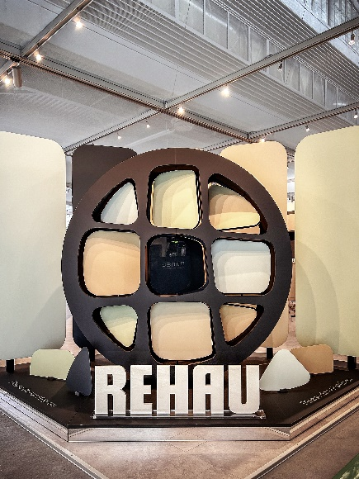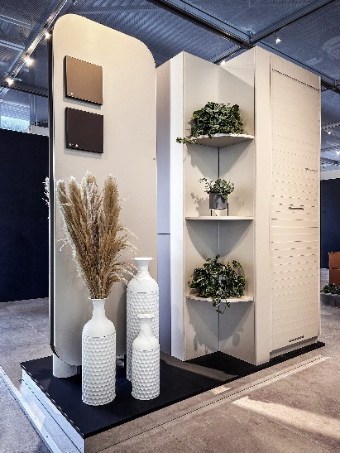
REHAU at SICAM 2024: RAUVISIO crystal Deep in
“Beauty for all shapes and forms“ Luna, Torba and Terriccio

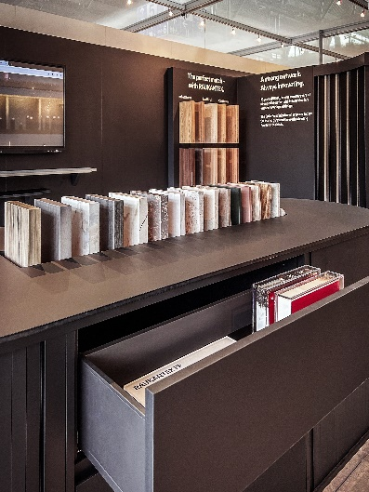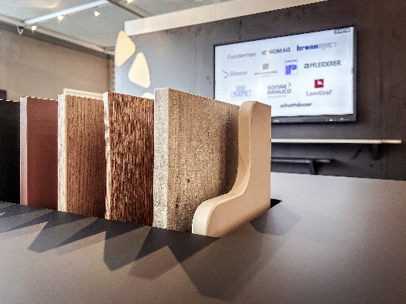
RAUKANTEX: Edgeband Maximum flexibility with
diversity in form, color and RAUKANTEX
function

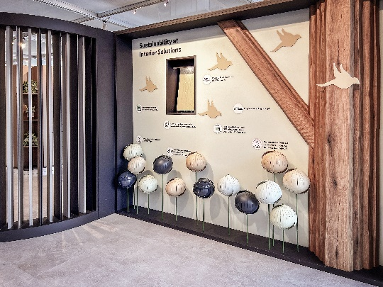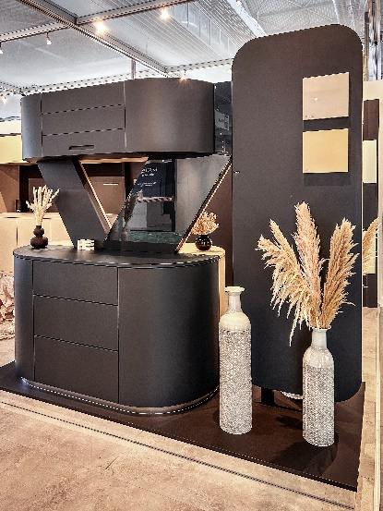
Sustainability and edgeband are Storage space solutions with
part of REHAU‘s programme FLIPDOOR combined with
RAUVISIO crystal

All images copyright of REHAU

Press contact:
GOOS COMMUNICATION GmbH & Co. KG
Stefanie Krüger
Geibelstraße 46a, 22303 Hamburg, GERMANY
Tel.: +49 40 2841787-53
rehau@goos-communication.com

REHAU Industries SE & Co. KG
Cornelia Martin
Rheniumhaus, 95111 Rehau, GERMANY
Tel.: +49 9283 77-2261
cornelia.martin@rehau.com

The Building Solutions, Window Solutions, Interior Solutions and Industrial Solutions divisions, which all operate independently in their respective markets, as well as the cross-divisional service units REHAU Services & Solutions, all fall under the umbrella of REHAU Industries. More than 12,000 employees at over 150 locations worldwide work together to keep improving lives through the use of innovative, sustainable technologies for the construction, furniture and industrial sectors: Engineering progress. Enhancing lives.
REHAU Industries is part of the global REHAU Group, which specialises in polymer-based solutions. The Group has more than 20,000 employees and generates an annual turnover of over EUR 4.5 billion.

